MAPacific Report Utility Tool

The MAPacific Report Utility tool is a simple application that automates the process of paging through the VISADPS report and taking that data and exporting it into an Excel Workbook with two Worksheets. The steps to starting the report processing are:

1. User must launch OutsideView 8.1 manually and establish a terminal session connection (TN3270 Model 5 Term Type 3278) to the VISADPS server.
2. User must login with their credential and navigate to the very first page of the report (It should display SARPAGE 1 and have the text TOP of DATA surrounded by ** in there).
3. Launch the MAPacific Report Utility application by double clicking on the MAPacificReportUtility.exe file. You should see the application come up. Once the application has come up, look on the bottom left corner of that application to the Status display bar. It should display the content: “OV Online”. This means that the tool has established a connection with the OutsideView 8.1 application.
4. Locate the Process Visa DPS Report button (labeled Process) and click on that button. This will start the report processing. You should notice in the OV emulation window that the screen is changing because of the utility tool paging through the report. The Status display bar should display the message: “Processing Visa Report”.
   1. Note in the top left corner of the report utility tool is the text box with label Report Date. This textbox is actually the filename that will be used to generate the Excel file. It will automatically be populated with the value: PrepaidImport(12/9/2010). The date will be the current date. If the report you are running does not match today’s date then a warning message will be placed into the Report Date textbox notifying of this discrepancy: “Warning: report's RUNDATE does not match today's date: 10/13/2010”. The date in this error message is the Report Runtime date and not today’s date. You will need to edit this message so that it forms a valid file name. Do not add the .xls extension to the filename.
5. When the report is finished being processed, the Status display bar will display the message “Finished processing Visa Report”. If there are any unrecognized Sub Client ID detected during the report processing the Edit Sub Client Preferences windows panel will automatically come up. You will need to go through the list of Client ID in the Client Branch Info Table and find entries in the table that have an empty value for the **Category** column. Once you have identified the entry click on the Category column for that entry. You should see a drop down list box of the possible values for Category. Select the correct value and then you should be done. If you also have some relational association with another ClientID then you will need to manually enter the value for the associated ClientID into the RelationParentSummary:

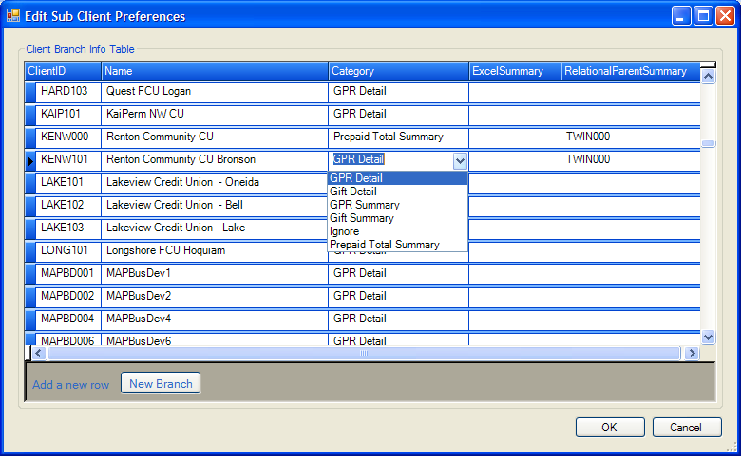

If you want to add a new branch, then click on the New Branch button. Enter the data into the last row of the table and once you are done click on the OK button. This will save your custom changes made in this table to a file named: BranchInfo.xml. After this panel is closed the data within the different data tables should be dynamically updated with the changes that were made. Note clicking on the Edit button will also bring up the same panel.

1. Look through the different tab panels to view the various data. The different data tables provide a quick glimpse into the data collected by this report utility tool. When you are finished looking through the different data tables and ready to export the report to an Excel file then first check that the Report Date textbox doesn’t contain a warning message. If it does then double check the contents and change the values accordingly. Next click on the button (Generate) which is located next to the label Generate Excel Spread Sheet. A excel file should be created in the directory that was specified in the Application Settings panel with the name specified in the Report Date textbox.
2. The files used to store the Application Settings dialog and the Edit Sub Client Preferences dialog are stored in the following location:
   1. C:\Documents and Settings\ USER PROFILE \Application Data\MAPReportUtility

The file names are:

MAPReportUtility.conf and BranchInfo.xml.